W.F.F.F

Fellowship Family Church

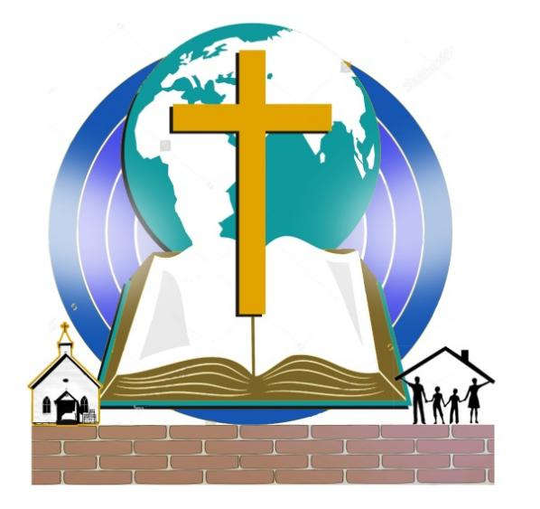
Department of Women

Titus: 2:3v
Likewise, teach the older women to be reverent in the way they live, not to be slanderers or addicted to much wine, but to teach what is good.

Purpose of women Ministry (women Department)
Women department is one of the key departments in a church which requires to be developed for the growth of the church in general. Knowing the role that women are called to play in the family according to the book of Proverbs: 14:1v every wise woman buildeth her house: and that’s the role of a women at the time of Jesus Ministry on earth.
Women being among the 120 disciples that accompaniedh Jesus in all the big gatherings held in different cities and towns. Thereby we see women supporting Jesu’s ministry in many ways. That’s why we see the Bible talking about this three women Joanna, Chuza and Susanna. Lukes: 8:1v And it came to pass afterward, that he went throughout every city and village, preaching and shewing the glad tidings of the kingdom of God: and the twelve were with him, 2v And certain women, which had been healed of evil spirits and infirmities, Mary called Magdalene, out of whom went seven devils, 3v And Joanna the wife of Chuza Herod's steward, and Susanna, and many others, which ministered unto him of their substance. 4v and when much people were gathered together, and were come to him out of every city, he spake by a parable:
This is a clear indication that shows if women department is run adequately it can do more in our local churches. It’s among the department that has people who are able to keep the balance of the family life and married members, because they are also the ones that run their homes on behalf e of their husbands, having more time with their children at home when the fathers are at work or attending others urgent matters.. That’s why the Bible says a wise woman builds her house, according to the book of Proverbs: 14:1v every wise woman buildeth her house: but the foolish plucketh it down with her hands.
Being aware that our churches today need (family) houses that are built, so that we can have strong churches. That can only happen by having a strong women department in our churches, having women who are very well trained and equipped. As Apostle Paul was teaching his spiritual son Titus saying << let old women teach the young women >> Titus:2: 3v The aged women likewise, that they be in behaviour as becometh holiness, not false accusers, not given to much wine, teachers of good things; 4v That they may teach the young women to be sober, to love their husbands, to love their children, 5v To be discreet, chaste, keepers at home, good, obedient to their own husbands, that the word of God be not blasphemed.
Therefore there is a call to develop women in these 3 areas.
- Spiritual
- Mentally ( soul, emotion )
- Physically
Once we are able to train women well, our churches will benefit from it, the women department is one of the pillars in the church that can really help our church to stand and become strong. Knowing they are also good in evangelism, as we saw in the early church where the Samaritan women was able to invite people to come see Jesus, according to the Book of John: 4:29v Come, see a man, which told me all things that ever I did: is not this the Christ? Which is already a kind of evangelism.
The bravery of women which we saw in the early church, where we see them going to the tomb to see Jesus. The Bible is telling us they went early in the morning. According to Matthew: 28:1v After the Sabbath, at dawn on the first day of the week, Mary Magdalene and the other Mary went to look at the tomb.
All this can give us more ideas of the women department programs and activities that can be developed to help women in our churches to grow spiritually, mentally and physically. Being like other church department as all the programs and activities that other church department can have.
As other departments they will have programs that will help them to grow spiritually, mentally and physically for example.
- Activities
- Having once a week women meeting ( spiritual Teachings )Titus:2:3v
- Training once a week ( hand work, other skills and learning) Proverbs:31:10v31
- Women evangelism ( reaching other women with the word of God) John: 4:29v
- Programs
- Women Conference
- Women camp or retreat
- Women department project
These are the programs and activities that can be run in the women department of our churches to develop women. So that they can be able to run the woman department from the training they will receive
N.B: knowing that training a woman is what will build our churches by having family as pillars
Because the Bible acknowledges that women builds her house, according to Proverbs: 14:1v every wise woman buildeth her house:
N.B: Knowing that training a woman is building a community that will produce good citizens for nation
Knowing all this it is showing us that women department is like other departments in our churches. Due to that it can help the church to grow spiritually and numerically, in running all its programs and activities. By having women department that is structured, having women who are trained to lead the department having a job description for each person in the department reporting to the pastor and church administration. That is when we can see the fruit and result of the women department in the church.

Pastors David Masongezi E.

Table of the Manual

- Who is a woman?

- What is women Department?

- How are the women whom are called to work with?

- What is the place of a woman in our church today?

- Why women department is important in the church?

- What type of teachings should women department teach to women?

- What kind of programs we can organize for women in our church?

- How to developing a need-based teachings in your church?

- How to evangelize and reach out women?

- What is a Christian women‘s perspectives about 21century women?

- How women department should be structure?

- Developing women department by starting project for job creation

